# **Network Intrusion Detection System**

**Koushik Gadeela**

**Ramteja Ponnaganti**

**Vinay Varma Aketi**

May 6, 2024

**Introduction:**

In an era, where our lives are increasingly intertwined with technology, the prevalence of network cyber-attacks has become a ubiquitous concern. From individuals to multinational corporations and governments, no entity is immune to the threat of cybercrime. These attacks manifest in various forms, from data breaches to ransomware extortion, leaving a trail of financial, reputational, and societal damage in their wake. Today, we'll explore the multifaceted challenges posed by network cyber-attacks and examine how individuals and organizations worldwide are confronting these threats with resilience, innovation, and collaboration.

Of course, some cyberattacks are worse than others. While some only cause short-term problems and outages, other, bigger cyber-attacks can be devastating, leaving companies with their reputations in tatters and a massive hole in their wallets. I guess you guys have heard about the Marriott Hotel data breach. It was hit by massive database breaches revealing the personal information of 5.2 million guests in 2018 and 2020, and later, by 2022, 20 GB of data was attacked again, which consisted of customer payment details and business documents. There were many cases like the Ukraine Power Grid attack and the 2014 Yahoo attack.

**Problem Statement:**

Cybersecurity threats pose significant risks to organizations and individuals worldwide. With cyberattacks becoming increasingly complex and sophisticated, there is an urgent need to develop robust methods for detection and mitigation. To meet these challenges, a network intrusion detection technique is proposed, utilizing the collective power of multiple machine learning algorithms.

**Literature Review:**

Network intrusion detection and prevention frameworks are widely used to monitor traffic and mitigate attacks. Network forensic schemes based on intrusion detection typically employ static and dynamic inspection of network traffic to detect anomalies. In existing Network Intrusion Detection Systems (NIDS), some identifies whether attack has happened in the system or not, some other identifies if the attack has happened, what type of attack it is. So, in our research problem, we only want to focus on only few types of attack that are important, occurring large in number. In that way, we are hoping to find out valid reasons, set of patterns that involves the properties of legitimate and suspicious activities, and finally machine learning techniques that identifies abnormal observations that are causing these attacks.

**Data Collection:**

The University of South Wales, Canberra, conducted validation on the UNSW-NB 15 dataset, wherein raw network packets were generated using the IXIA PerfectStorm tool within the Cyber Range Lab. The objective was to create a mix of authentic, contemporary normal activities and artificially generated attack behaviors. The dataset is available in CSV format, split into two files. The training data file comprises 175,342 records, with a size of 32.5 MB, while the testing data file contains 82,333 records, with a size of 15.7 MB.

So, in our dataset we have "attack_cat" as the target variable.

Types of Attack:

* + Normal
  + Fuzzers
  + Analysis
  + Backdoors
  + DoS (Denial of Service)
  + Exploits
  + Generic
  + Reconnaissance
  + Shellcode
  + Worms

**Data Preprocessing:**

In target variable "attack_cat", we are removing all instances corresponding to these categories from both the training and testing datasets. There are relatively fewer instances of the following attack categories:

* + Analysis
  + Backdoor
  + Shellcode
  + Worms

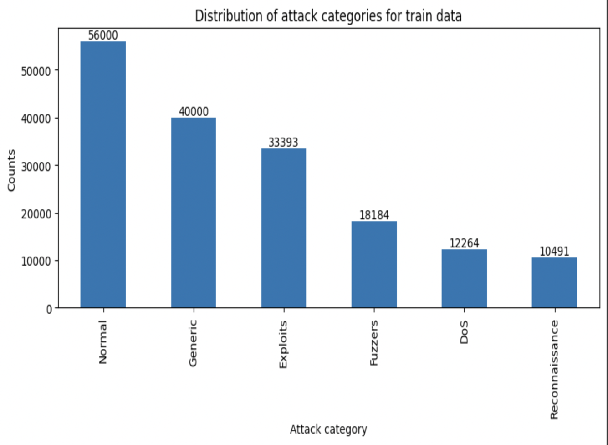

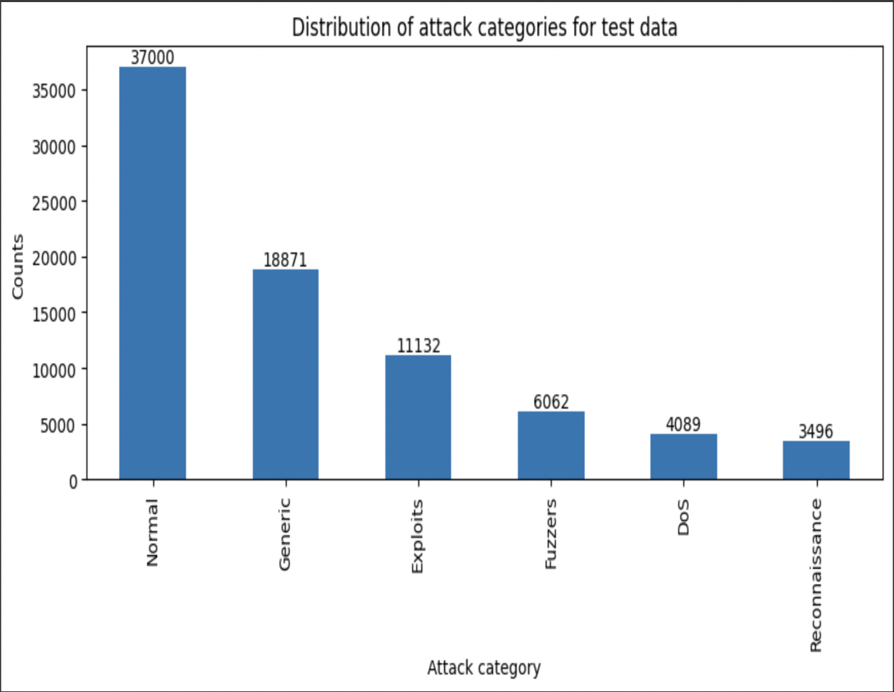

**Feature Engineering:**

The dataset under analysis comprises 43 attributes, encompassing both dependent and independent variables. To enhance accuracy and streamline analysis, a preprocessing step involved the removal of unnecessary attributes. This was achieved through the implementation of various techniques, with the correlation matrix method being a prominent approach. By employing this technique, a subset of 28 attributes was identified as relevant for further analysis, facilitating a more focused and efficient exploration of the dataset.

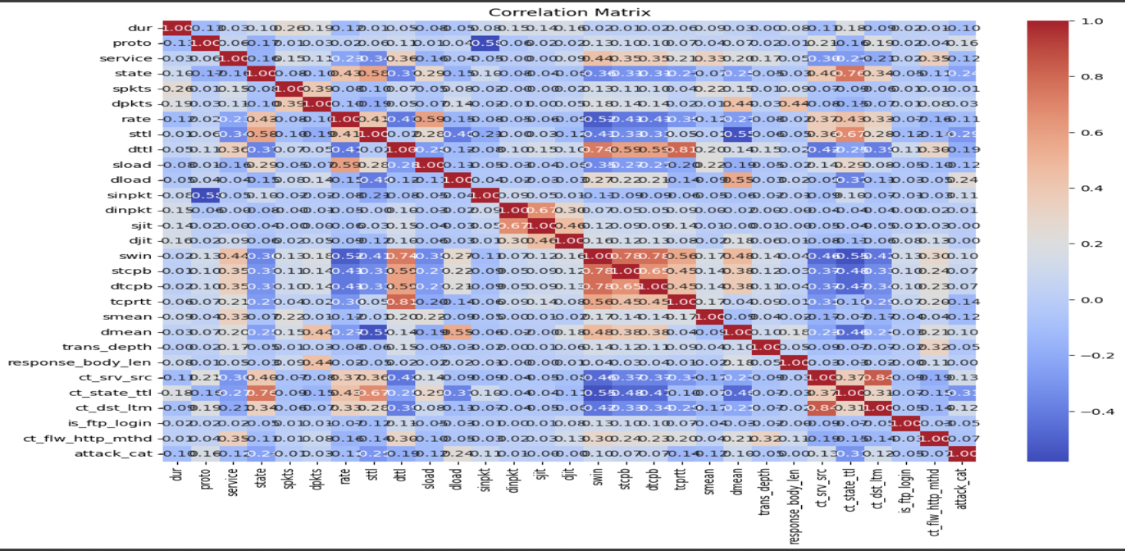

After analyzing the correlation matrix, we excluded 15 dependent features, focusing our dataset on the most relevant 28 attributes.

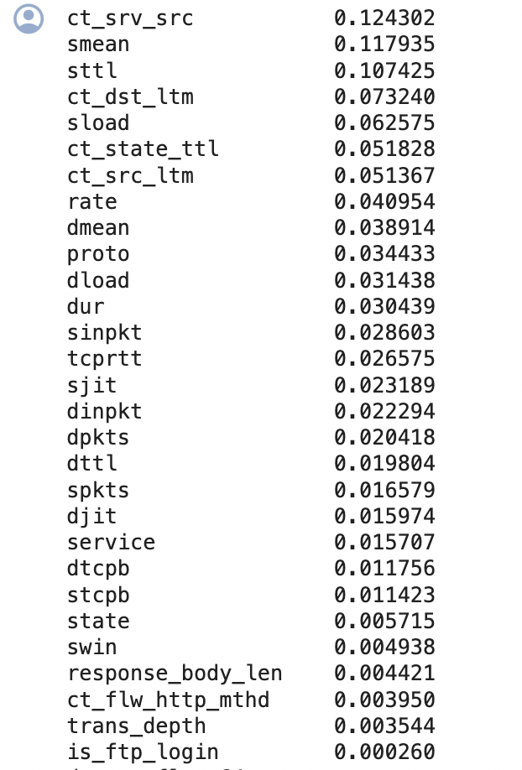

**Research Questions:**

* How can machine learning algorithms be applied to analyze the UNSW-NB15 dataset and detect different types of cyber-attacks?
* What are the key features and patterns indicative of malicious activities in network traffic data?
* How do different machine learning models perform in terms of accuracy, sensitivity, and specificity for cybersecurity threat detection?

**Exploratory Data Analysis:**

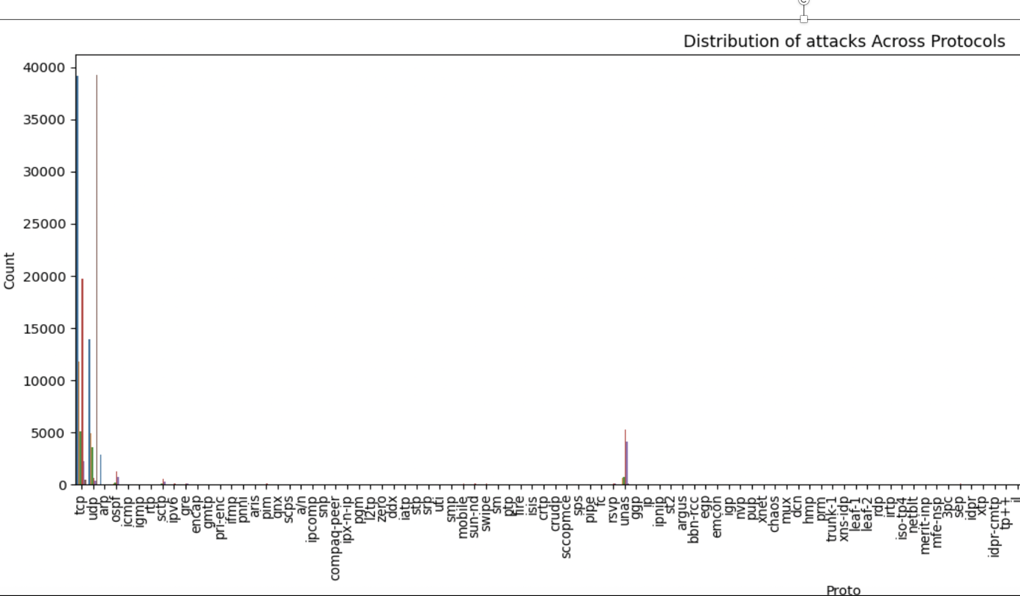

Through an examination of the distribution of protocols feature, it was observed that a significant portion of cyber-attacks occurred within the TCP and UDP protocols. This finding suggests that these protocols are particularly vulnerable to malicious activities, highlighting the importance of implementing robust security measures to mitigate risks associated with these communication protocols.

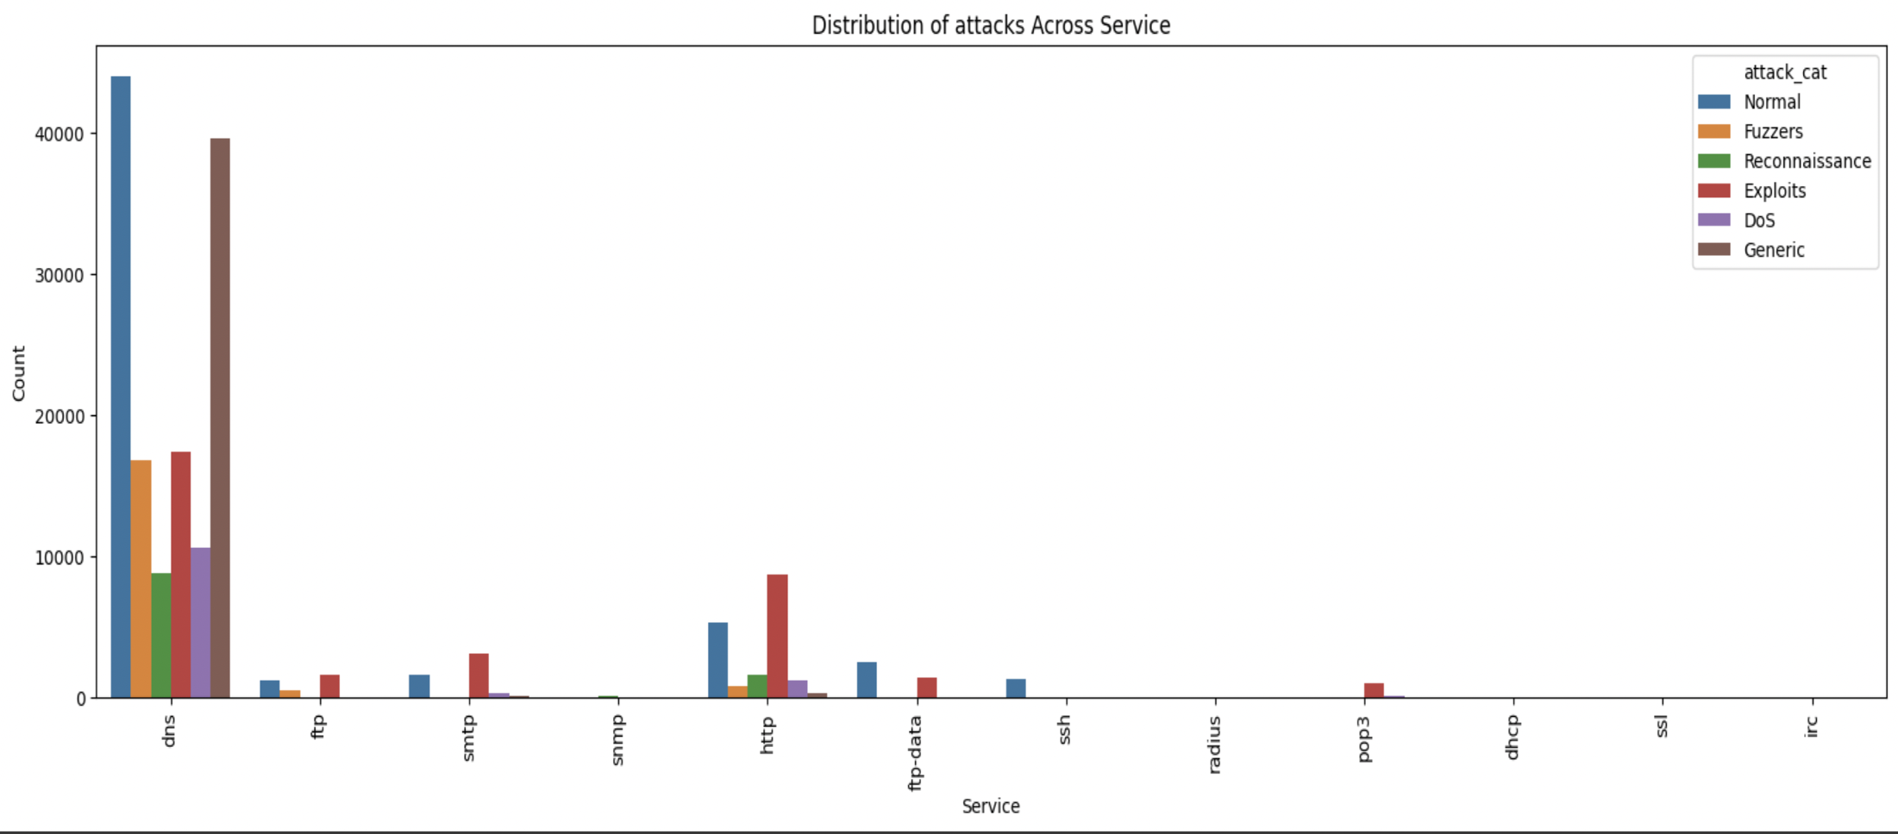

The Domain Name System (DNS) emerges as a crucial networking service where most cyber-attacks are occurring. This underscores the critical role of DNS in facilitating internet communication and highlights its susceptibility to malicious activities. Understanding this trend emphasizes the need for heightened security measures and proactive monitoring within the DNS infrastructure to effectively mitigate cyber threats and safeguard network integrity.

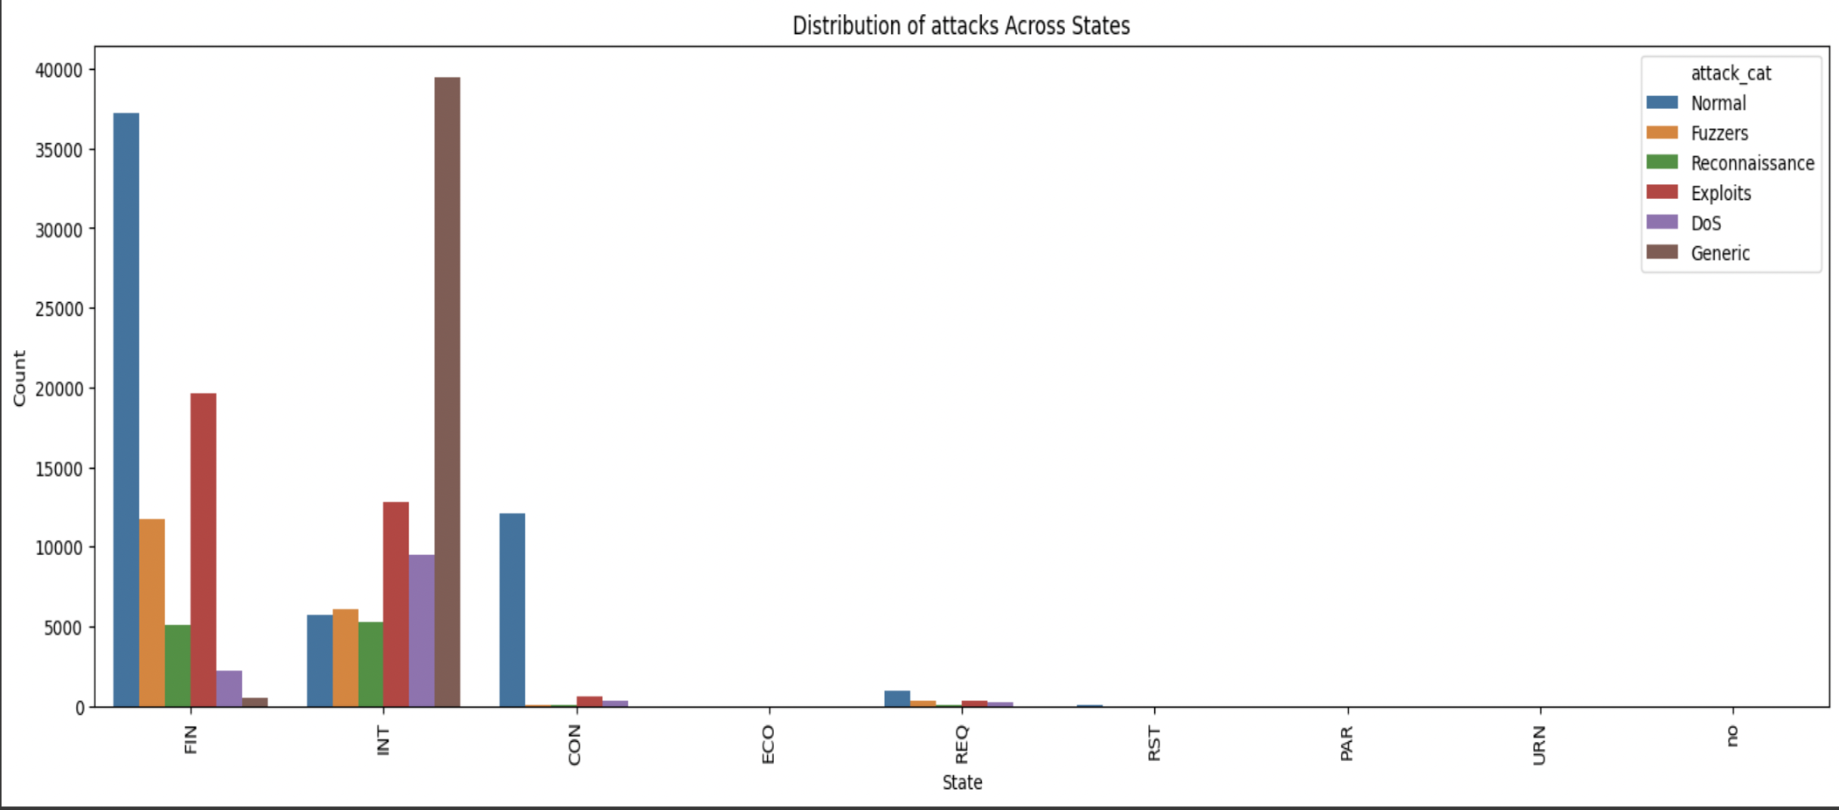

The dataset reveals a notable concentration of cyber-attacks during the "initiation" and "finished" states. This insight highlights the critical junctures in the cyber-attack lifecycle where adversaries most actively exploit vulnerabilities and execute malicious activities. Understanding this trend underscores the importance of fortifying defenses and implementing robust security measures during these specific phases to effectively mitigate threats and safeguard network integrity.

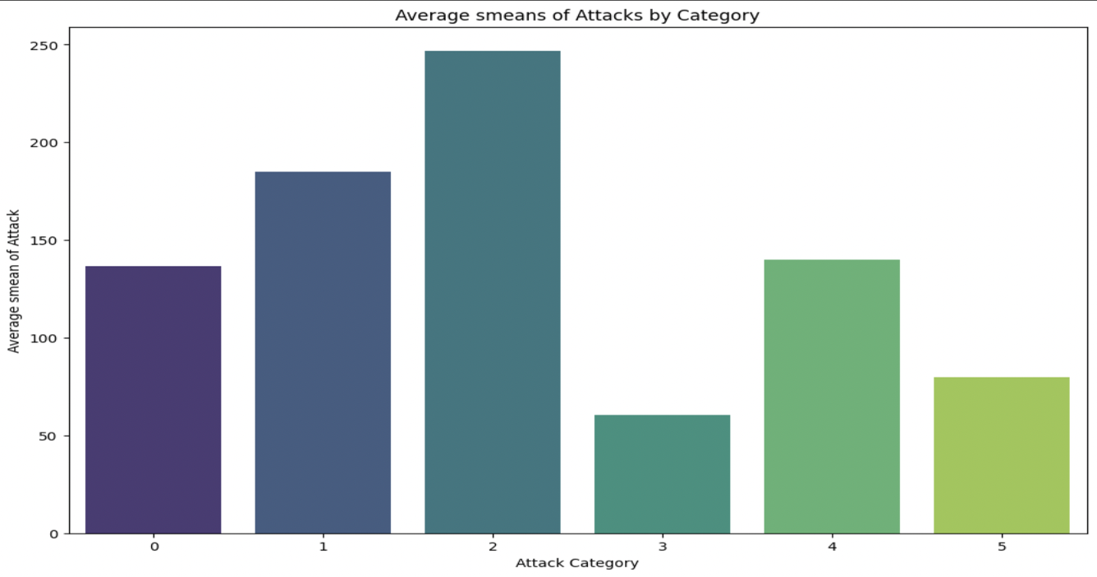

The above graph illustrates the "Average smean of Attacks by Category," presenting a comprehensive overview of the mean flow packet size transmitted by the source in network traffic data sets across various attack categories. This metric offers valuable insights into the typical packet size distribution associated with each attack category's activity on the network. Analyzing these average smeans enables the identification of distinct patterns in packet size behavior, facilitating the detection and characterization of malicious activities within the network.

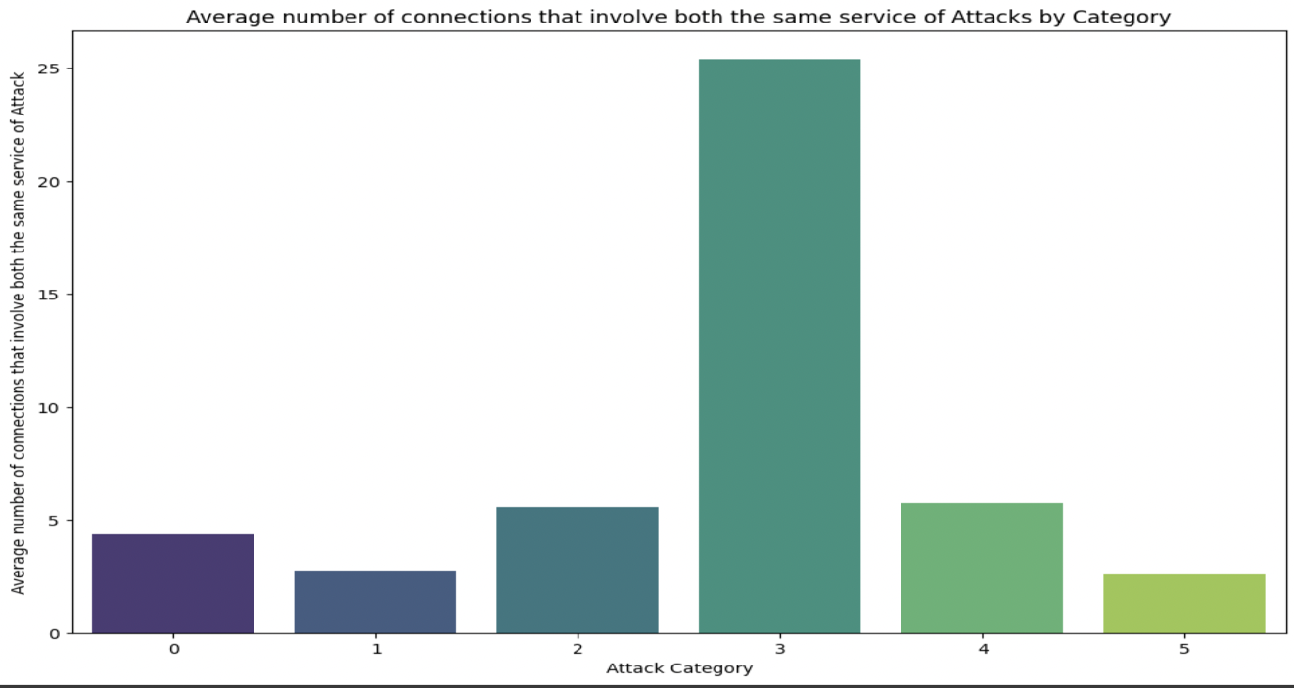

The above graph "Average number of connections that involve the same service of Attacks by Category" visually represents the mean number of connections that involve the same service within network traffic datasets across different attack categories. This metric offers insights into the frequency of connections involving identical services in various attack scenarios. By analyzing these averages, patterns emerge regarding the commonality of service usage within different attack categories, aiding in the understanding and detection of malicious activities within the network.

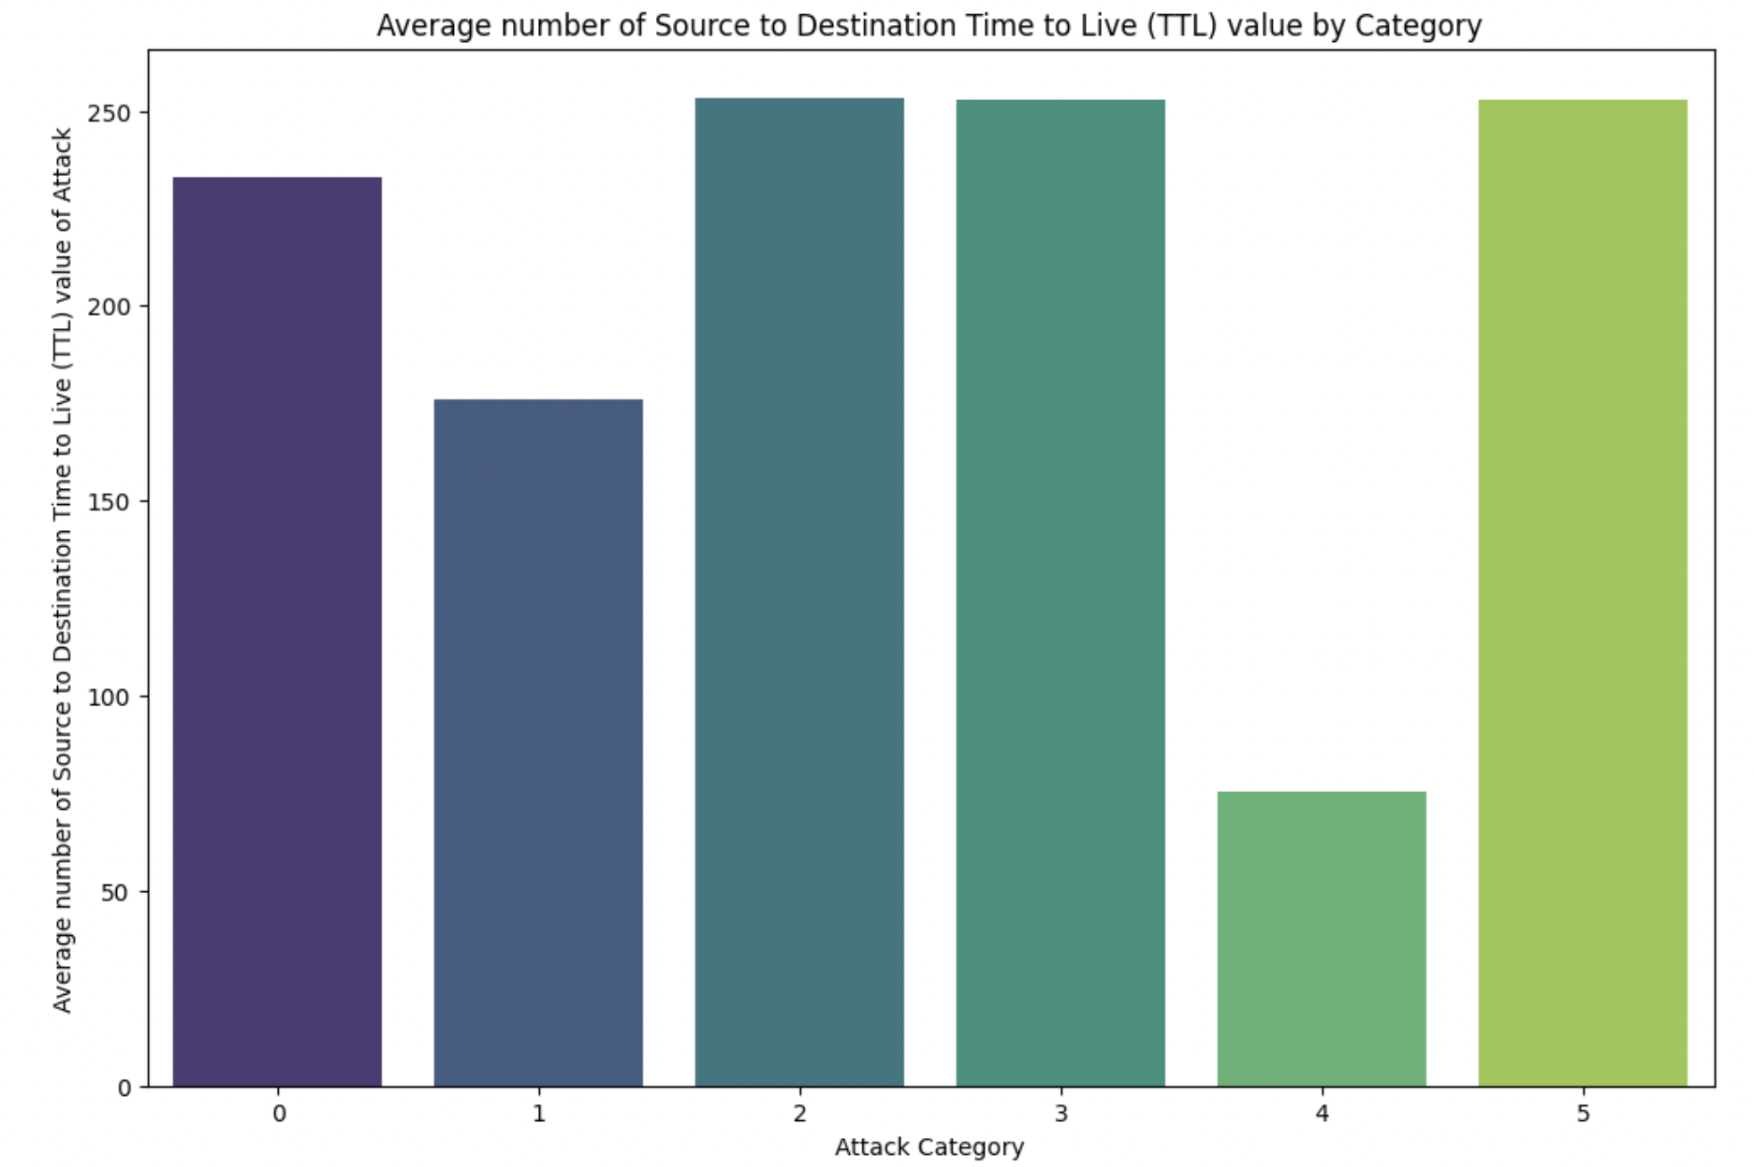

The above graph depicted above showcases key insights into network communication dynamics during attacks, focusing on the Average Source to Destination Time to Live (TTL) value. This metric plays a pivotal role in understanding the lifespan of packets as they traverse routers, with variations indicating distinct attack types and their impact on network infrastructure. By analyzing the "Average TTL value of Attack" and "Average TTL value by Category," significant patterns emerge, offering valuable insights for fortifying network defenses and mitigating potential risks effectively.

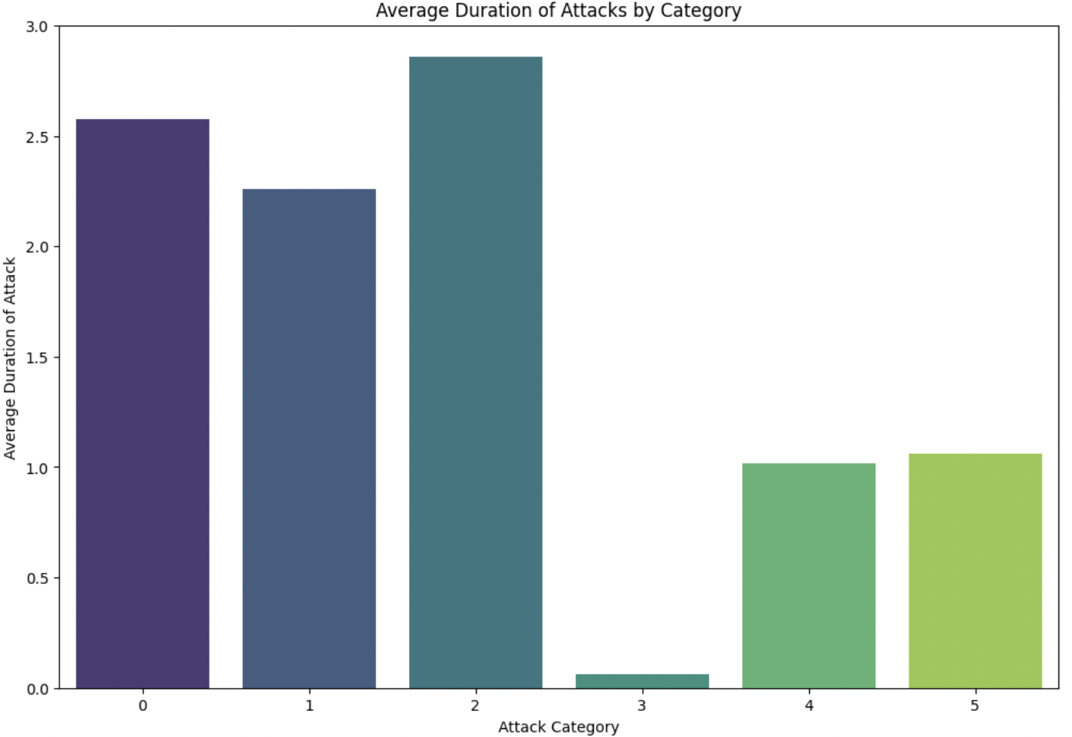

The above graph titled "Average Duration of Attacks by Category" presents a comprehensive view of attack durations within network traffic data. Utilizing the "dur" variable, which signifies the total duration of recorded activities, the graph offers valuable insights into the temporal characteristics of attacks across different categories. With the y-axis labeled as 'Average Duration of Attack,' each category's average duration is clearly depicted, providing a nuanced understanding of how attack durations vary within the dataset. This visualization serves as a crucial tool for analyzing attack patterns and trends, enabling cybersecurity professionals to better comprehend and respond to threats effectively.

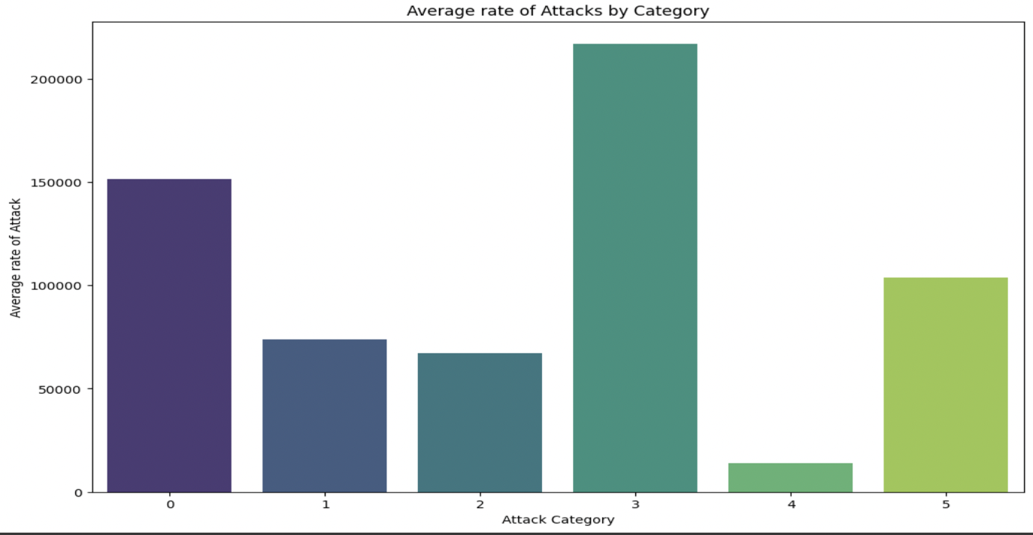

The above graph titled "Average Rate of Attacks by Category," the y-axis reflects attack frequency per category. This concise visualization aids in identifying high-risk areas and enables proactive cybersecurity strategies. Understanding attack distribution enhances threat detection and response capabilities, strengthening overall network security.

**Machine Learning Models’ Performance Assessment:**

**Traditional Machine Learning Models:**

* **Logistic Regression:**
  + The logistic regression model exhibits bias but lacks variance in its performance evaluation.
  + In multi-classification scenarios, focusing solely on accuracy isn't sufficient as it pertains to overall classification rather than individual class distinctions.
  + For dealing with unbalanced classification problems, accuracy alone is insufficient; hence, metrics like precision, recall, and F1-score, tailored to each class, are essential.
  + While all metrics contribute to assessing classifier performance, the primary emphasis is on the F1-score due to its harmonized evaluation of precision and recall for each class.
  + The model performs well for majority classes (1, 3, and 4) compared to minority classes (0, 2, and 5).
  + To address this class imbalance, we tried below methods:
    1. Class Weighting
    2. Resampling Techniques
    3. Ensemble Methods

# **Logistic Regression with Class Weighting:**

* + Balanced class weighting aims to address class imbalance by assigning higher penalties to misclassifications of minority classes compared to majority classes.
  + This approach encourages the model to prioritize learning from minority class examples during training by assigning them higher weights.
  + The implementation of balanced class weighting resulted in a slight improvement in the F1-score for minority classes 0 and 2.
  + However, there was no discernible impact on the F1-score for class 5, indicating that the weighting strategy may not effectively address the imbalance for this class.

# **Logistic Regression with SMOTE (Synthetic Minority Over-sampling Technique):**

* + SMOTE (Synthetic Minority Over-sampling Technique) is employed to tackle class imbalance by generating synthetic samples for the minority class.
  + The technique aims to balance the class distribution by increasing the representation of minority class instances.
  + Upon applying SMOTE, the results indicate that, apart from class 4, the performance metrics for all other classes have significantly decreased.
  + This suggests that while SMOTE may effectively balance the dataset, it doesn't necessarily lead to improved performance for all classes.
  + The observed decrease in performance for most classes post-SMOTE implementation underscores the importance of careful consideration and evaluation of the technique's impact on specific class distributions.

# **Logistic Regression with Grid search:**

* + GridSearchCV assists in finding the optimal combination of hyperparameters, aiming to maximize model performance.
  + The process can enhance predictive accuracy, precision, recall, or other performance metrics, depending on the problem at hand.
  + To improve model performance, a grid search with penalization is conducted to explore different hyperparameter combinations.
  + However, the results obtained from GridSearchCV for the logistic regression model are consistent with those from the base model, indicating no significant improvement.
  + After exhaustively exploring various possibilities with logistic regression, it is concluded that the model is not suitable for addressing the problem effectively.
  + This suggests the need to explore alternative models or techniques better suited to the specific characteristics and challenges of the dataset.

# **Decision Tree Classifier:**

* + A decision tree is structured hierarchically, with nodes representing features, branches depicting decisions based on those features, and leaf nodes representing outcomes.
  + The decision tree classifier model demonstrates improved performance across all classes compared to other models.
  + However, decision trees are prone to high variance, as evidenced by significant differences between training and test data accuracies.
  + To mitigate this issue, pruning techniques can be implemented, such as constraining the depth of the tree or setting thresholds for minimum samples split and minimum samples per leaf.
  + Pruning techniques aim to simplify the decision tree structure, reducing overfitting and improving generalization performance on unseen data.
  + By implementing pruning techniques, the decision tree model can achieve a better balance between bias and variance, leading to more reliable and robust predictions.

# **the depth of the tree or the minimum samples split and Minimum Samples Leaf to reduce variance:**

* + **max_depth**: This parameter determines the maximum depth of the decision tree, limiting the length of the longest path from the root node to a leaf node. Setting max_depth helps prevent overfitting by restricting the complexity of the tree.
  + **min_samples_split**: Specifies the minimum number of samples required to split an internal node. Nodes with fewer samples than min_samples_split won't split further, becoming leaf nodes instead. Increasing min_samples_split prevents premature splitting, aiding in combating overfitting.
  + **min_samples_leaf**: Sets the minimum number of samples required at a leaf node. If a split results in a leaf node with fewer samples than min_samples_leaf, the split is deemed invalid, halting further splitting. Elevating min_samples_leaf promotes more generalized tree structures, mitigating overfitting by enforcing leaf nodes to have a minimum number of samples.
  + **random_state**: This parameter ensures the reproducibility of the estimator's results. By assigning a specific value to random_state, results remain consistent across multiple runs. Consistent random_state values yield reproducible outcomes, facilitating result comparison and interpretation across experiments.
  + After implementing pruning techniques such as setting constraints on max_depth, min_samples_split, and min_samples_leaf, a slight reduction in variance is observed. However, it's noted that the scores for the minority class 0 have decreased, indicating potential trade-offs between variance reduction and performance on specific class distributions.

# **Decision Tree Classifier with Grid Search:**

* + Following the implementation of decision tree with grid search, notable performance improvements are observed across most classes, with exceptions noted for minority classes 0 and 5.
  + Despite the challenges encountered with minority classes 0 and 5, the decision tree classifier demonstrates strong performance overall.
  + Based on the results obtained, it's concluded that the decision tree classifier is the most suitable model for addressing the problem at hand.
  + While there were challenges in improving metric scores for certain classes, particularly the minority classes, the primary concern revolved around addressing variance within the model.
  + Despite facing challenges with class-specific metric improvements, the decision tree classifier's overall performance and suitability for the problem outweigh these concerns, making it the preferred choice for the task.

**Ensemble Learning Methods:**

**Random Forest Classifier:**

* + Despite observing a reduction in variance, notable disparities persist between the performance of the test and train data sets, indicating potential overfitting to the train data.
  + The higher performance metrics on the train data compared to the test data suggest a tendency for the model to overly conform to the training data, compromising generalization to unseen data.
  + To mitigate overfitting, various parameters have been explored and adjusted within the random forest classifier.
  + By fine-tuning these parameters, efforts are made to strike a balance between model complexity and generalization performance.

# **Random Forest code with regularization and feature sampling to reduce** variance:

* + **n_estimators**: This parameter defines the number of decision trees within the random forest ensemble. Increasing n_estimators can enhance the forest's performance by averaging out predictions and reducing overfitting, up to a certain point. More trees generally improve the model's ability to generalize by capturing a broader range of patterns in the data.
  + **max_features**: Specifies the maximum number of features considered when searching for the best split in each decision tree. This parameter can take on different values, such as 'sqrt' (the square root of the total number of features), which limits the number of features considered at each split. Constraining max_features help prevent individual trees from becoming too complex and overfitting to the training data.
  + After incorporating regularization and feature sampling hyperparameters, a notable reduction in variance is observed within the random forest model.
  + Similar to the behavior observed with decision trees, the metric scores for class 0 have decreased while attempting to mitigate variance.
  + This trade-off between reducing variance and maintaining performance on specific classes highlights the importance of carefully tuning hyperparameters to achieve a balance between model complexity and generalization performance.

# **Gradient Boosting Classifier:**

* + Gradient boosting demonstrates strong performance across all classes except for class 0.

# **Xtreme Gradient Boosting:**

* + We could see by implementing XGradientBoosting Classifier, there is improvement in performance metrics compared to gradient boosting.

# **Bagging Classifier:**

* + Decision trees often exhibit high variance, prompting the application of the bagging method, which involves training multiple models independently and averaging their predictions to mitigate variance.
  + Bagging employs homogeneous weak learners, such as decision trees, and constructs them deep, resulting in high variance but low bias for individual trees.
  + By averaging the predictions of multiple decision trees, bagging reduces overall variance while maintaining or improving accuracy.
  + Similarly, the bagging method is applied to random forests, where each tree is trained on a random subset of the data to further reduce variance.
  + The primary goal of bagging is to create an ensemble model with lower variance than its individual components, leading to more robust and accurate predictions.

**Stacking:**

* + Stacking involves training multiple weak learners and combining their predictions using a meta-model to improve overall performance.
  + To build a stacking model, two key components must be defined: the L learners (base models) and the meta-model responsible for combining their predictions.
  + The Stacking Classifier exhibits strong performance on both training and test data, showing consistent performance across various classes.
  + However, there is a slight decrease in performance when moving from training to test data, indicating potential overfitting.
  + This suggests that while stacking effectively leverages diverse models for improved predictions, careful consideration of model complexity and generalization is necessary to avoid overfitting and ensure robust performance on unseen data.
* **Fully Connected Neural Networks (FNN):**
  + Consistent but relatively low performance observed across both training and test data, with accuracy scores of 56% and 60%.
  + Struggles to effectively distinguish between certain classes, particularly minority classes 0, 2, and 5.
  + Despite using ***Adamw*** optimizer does not yield any improvement in performance.
* **Convolutional Neural Network (CNN):**
  + Shows improved performance compared to FNN, especially in treating minority classes 2 and 5.
  + However, there is no significant improvement for class 0.
  + Overall good performance across most classes but struggles with class 0.
  + Despite using ***Adamw*** optimizer, there is only improvement in precision for minority class 0, with no impact on recall and F1-score.
* **Recurrent Neural Networks (RNN):**
  + Performs reasonably well on most classes but struggles significantly with class 0.
  + Despite applying the ***Adamw*** optimizer, there is no impact on class 0's performance.



**Future Considerations:**

* **Enhanced Feature Engineering:**
  + **Deep Learning-Based Feature Learning**: Utilize deep learning architectures, such as convolutional neural networks (CNNs) or recurrent neural networks (RNNs), to automatically learn discriminative features directly from raw network traffic data. For example, you can use CNNs to extract spatial patterns from packet headers or RNNs to capture temporal dependencies in network traffic sequences.
  + **Domain Knowledge Incorporation**: Collaborate with cybersecurity experts to incorporate domain knowledge into feature engineering. This could involve designing handcrafted features based on known indicators of compromise (IoCs) or leveraging expert insights to guide the selection and transformation of features. For instance, you can engineer features related to known attack signatures, network protocols, or anomalous behavior patterns.
* Given the success of decision trees and random forests in achieving better performance metrics such as F1-score, accuracy, precision, and recall, here are modified future implications focusing on further enhancing these methods.
  + **Hierarchical Ensembles**: Construct hierarchical ensemble structures where decision trees and random forests are combined at multiple levels of abstraction. For example, you can build an ensemble of decision trees at the leaf level and then combine their predictions using a random forest meta-learner.
  + **Distributed Computing**: Explore distributed computing frameworks, such as Apache Spark or Dask, to scale decision tree and random forest training across multiple nodes in a cluster. Distributed training can significantly reduce training times and enable the handling of larger datasets.
  + **Model Compression**: Investigate techniques for model compression and optimization to reduce the memory footprint and computational overhead of decision trees and random forests, particularly in resource-constrained environments such as edge devices or embedded systems.
* Real-Time Detection and Response:
  + **Stream Processing Frameworks**: Implement real-time analysis of streaming network traffic data using stream processing frameworks such as Apache Kafka, Apache Flink, or Apache Storm. These frameworks enable high-throughput, low-latency processing of data streams and are well-suited for building real-time intrusion detection systems.
  + **Automated Response Mechanisms**: Develop algorithms for automated response actions based on the detection of cyber-attacks. For example, you can integrate your intrusion detection system with network firewalls, intrusion prevention systems (IPS), or security information and event management (SIEM) systems to automatically trigger response actions such as blocking malicious IP addresses, isolating compromised devices, or generating alerts for security analysts.
* **Enhanced Cybersecurity Measures:**
  + Developing an effective network intrusion detection system utilizing machine learning algorithms could substantially enhance cybersecurity measures.
  + This system would aid organizations and individuals in better protecting sensitive data and networks from various cyber threats.
* **Cost Savings for Businesses:** 
  + Improved cybersecurity measures have the potential to generate significant cost savings for businesses.
  + By reducing financial losses linked to data breaches, system downtime, and reputation damage, businesses can mitigate the impact of cybersecurity incidents.
  + Investing in proactive threat detection solutions enables businesses to avoid costly cybersecurity breaches, ultimately leading to long-term financial savings and operational stability.